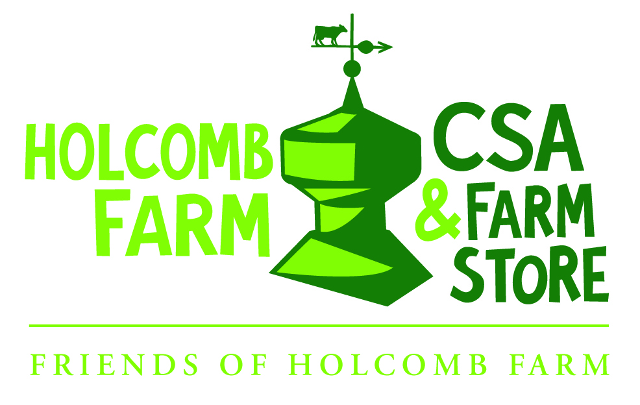
Summer 2020 CSA Sign-Up Form

Name: _______________________________________________________________
Address: _______________________________________________________________
Email: _______________________________________________________________
Telephone: _______________________________________________________________
Farm Share
- Full Share $640
- Half Share $360

West Hartford Delivery
- Full Share price before 02/1/20 is $625, after 02/1/20 it is $640
- Half Share price before 02/1/20 is $350, after 02/1/20 it is $360

Workplace Share
- $500 Your workplace: ____________________________

Please consider adding $25 to your CSA subscription to support our Fresh Access program. It makes a difference to individuals and families in need. Thank you!

Total Enclosed: __________________________
Mail checks to: Holcomb Farm, Inc. 113 Simsbury Road, West Granby, CT 06090 or pay in full by e-check or credit card at www.holcombfarm.org. (Paying by check or e-check saves us on processing fees!) Installment payments: 1/3 payment due at sign-up and balance due at Week #1 pick-up.
Splitting a share or want others to receive new/updates from the Farm? Please list their names and emails:
Name: __________________________________ Email: ____________________________
Name: __________________________________ Email: ____________________________

